| **Test Name** | Manually start pump when pump is not running [Est.Timer] |
| --- | --- |
| **Use Case Tested:** | Manually turn the pump on |
| **Test Description:** | This test verifies that the pump can be turned on using the manual on/off switch, and the estimated timer value is sent |
| **Pre-conditions** | * Pump Not Running; * System State of Pump: Not running; * ThingsBoard has not asked the pump to start running via manual operation. * Automation: Off. * Est. Timer: On. * Custom Timer: Off. |
| **Post-conditions** | * Running LED: On * Manual Switch: On * Transmit Status: Successful * Pump On with Est. Timer value |
| **Notes:** |  |

|  | **TEST STEP** | **EXPECTED TEST RESULTS** |
| --- | --- | --- |
|  | Set tank level sensor server attribute fillTimer to 2. | * Est. Fill Timer on dashboard shows 00h 02m. |
|  | Use the Dash to send a manual pump on message. | * Switch changes from off to on. * Transmit status becomes “In-Transit”. * Event Log shows Manual On message. * A downlink command is scheduled with payload 0x03 0x00 0x02. |
|  | Send a status message from pump controller. | * Pump controller sends a status message with pumpRunning: 0. * Dash still displays “In-Transit”. |
|  |  | * Pump controller receives command and switches pump on with a message giving the timer information. * Pump controller sends a status message with pumpRunning: 1. * Dash displays transmit status success. |
|  | Wait 2 minutes | * Pump controller switches pump off, sends a status message with pumpRunning: 0. * Dashboard updates to show pump not running. |

|  |  |  |  |  |  |
| --- | --- | --- | --- | --- | --- |
| **Test Data Table** | | | | | |
|  | **1** | **2** | **3** | **4** | **5** |
| [Data field 1] | [data set 1 input value for field 1] |  |  |  |  |
| [Data field 2] | [data set 1 input value for field 2] |  |  |  |  |
| [Data field 3] | [data set 1 input value for field 3] |  |  |  |  |

**Results**

05/09/2020

**SUCCESS!**

Manual On sent. Received with correct timer value. Dash updated.

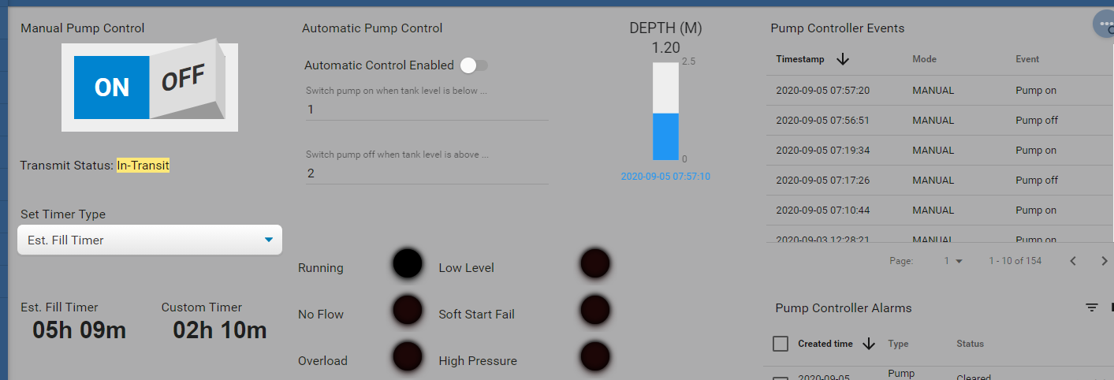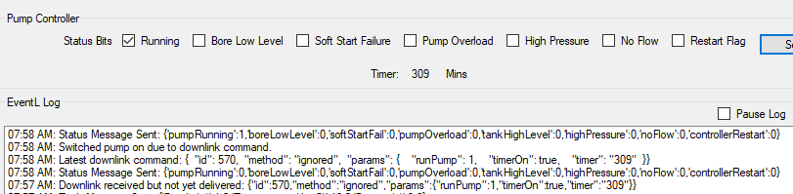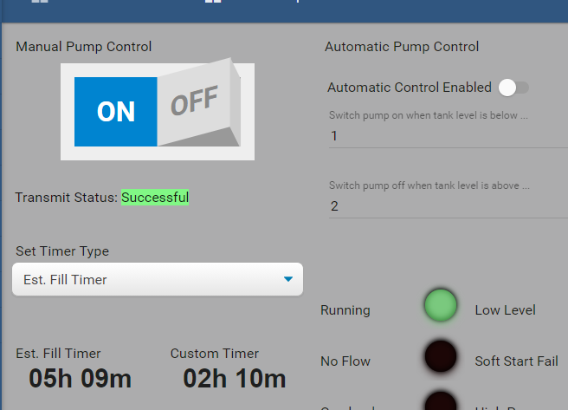

9/9/2020 – On site test at OAI.

Success.

Step 1.

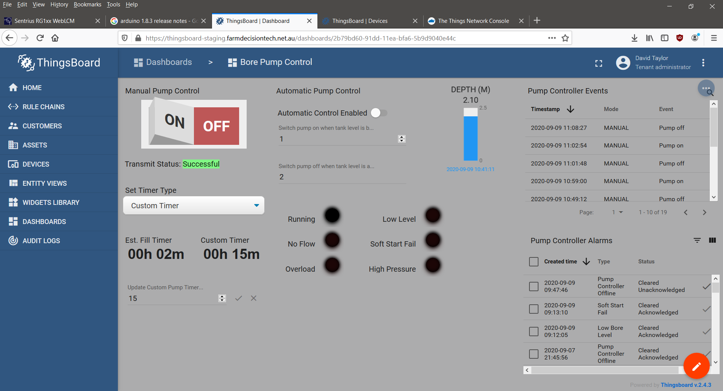

Step 2.

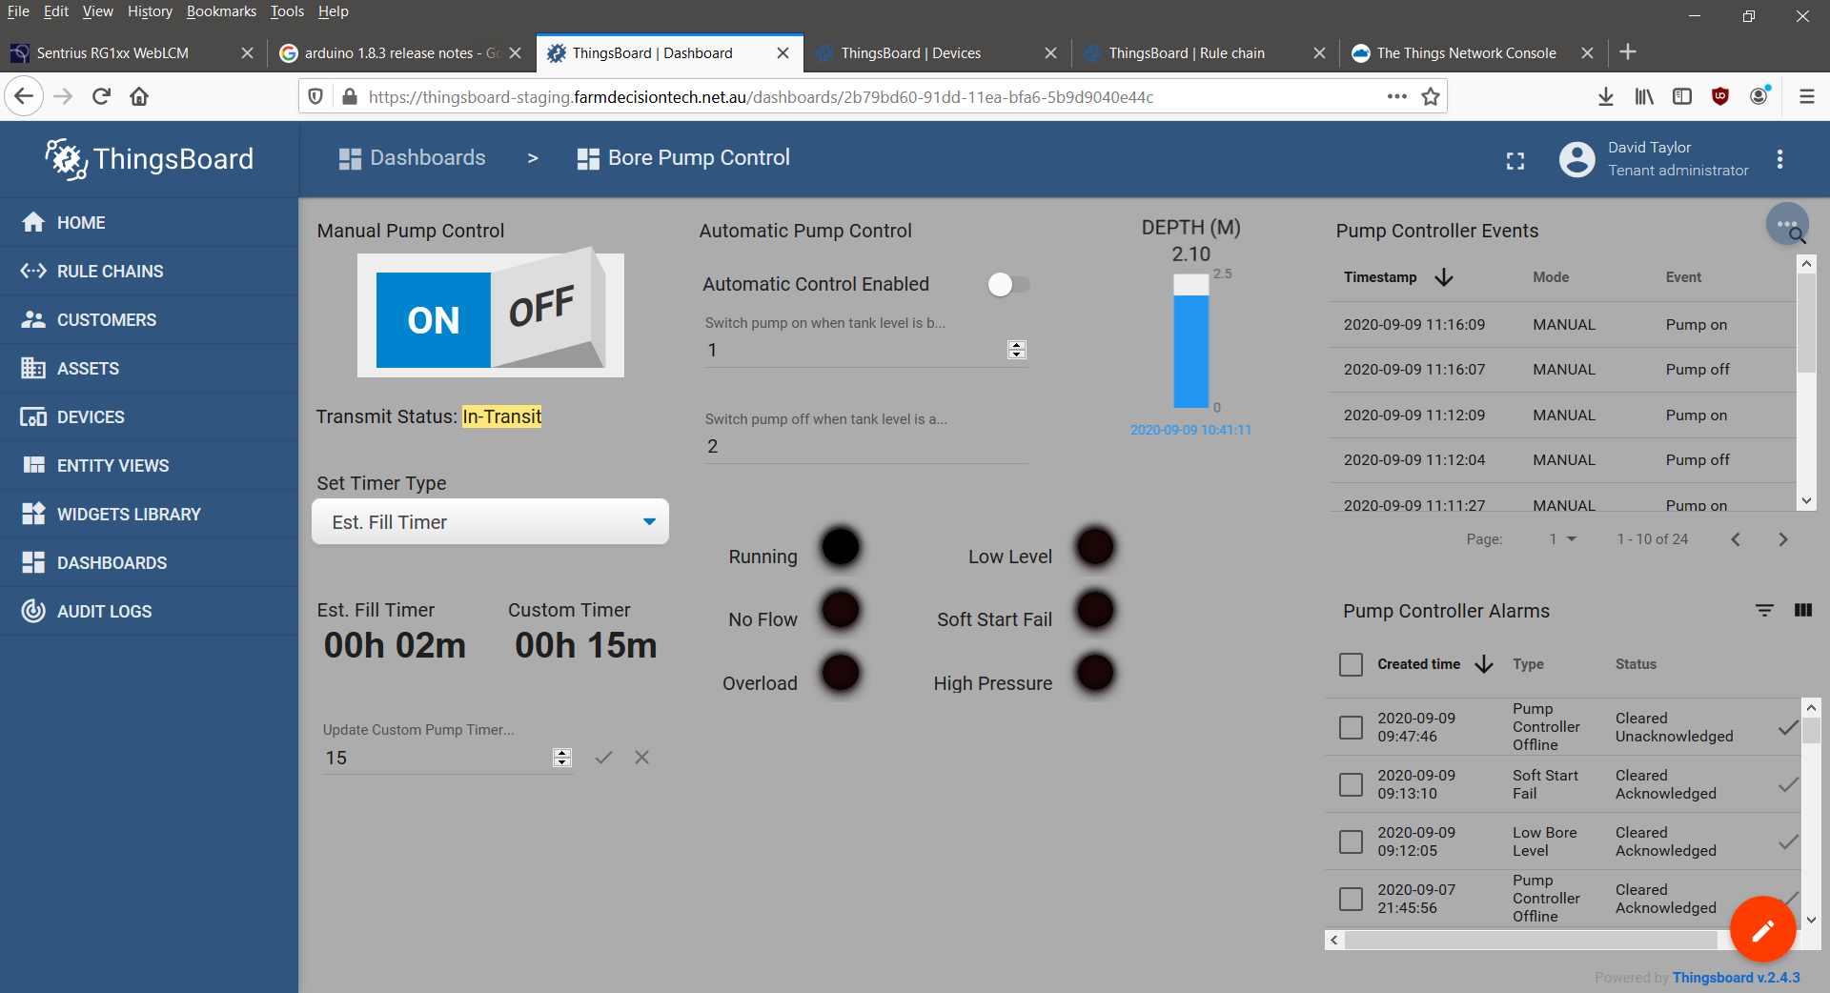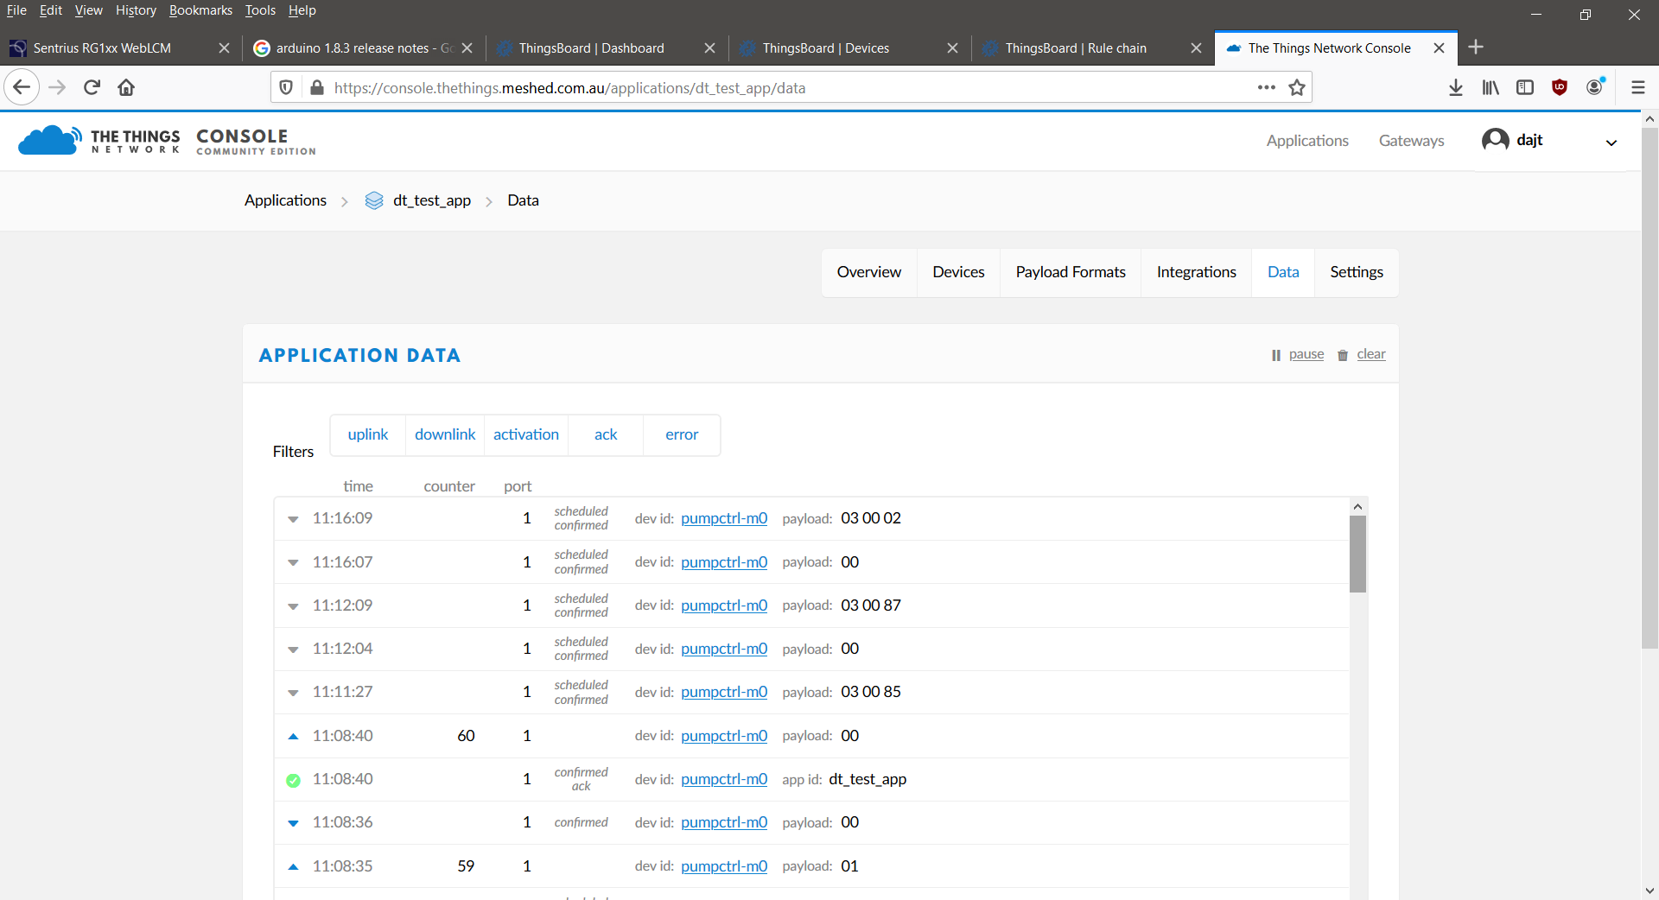

Steps 3 & 4.

11:17:06.701 -> Send operator requested status message.

11:17:06.701 -> LoRaWAN will encode and send this message: {'pumpRunning':0,'boreLowLevel':0,'softStartFail':0,'pumpOverload':0,'controllerRestart':0,'highPressure':0,'noFlow':0}

11:17:06.701 -> Sending status byte: 00

11:17:07.796 -> EV_TXCOMPLETE (includes waiting for RX windows)

11:17:07.796 -> Received reply with 3 bytes:

11:17:07.796 -> 03 00 02

11:17:07.796 -> callback got data 3

11:17:07.796 -> Switched pump on.

11:17:07.796 -> Starting one-shot timer.

11:17:07.796 -> Timer in minutes: 2

11:17:07.796 -> Sending status due to state change.

11:17:07.796 -> LoRaWAN will encode and send this message: {'pumpRunning':1,'boreLowLevel':0,'softStartFail':0,'pumpOverload':0,'controllerRestart':0,'highPressure':0,'noFlow':0}

11:17:07.796 -> Sending status byte: 01

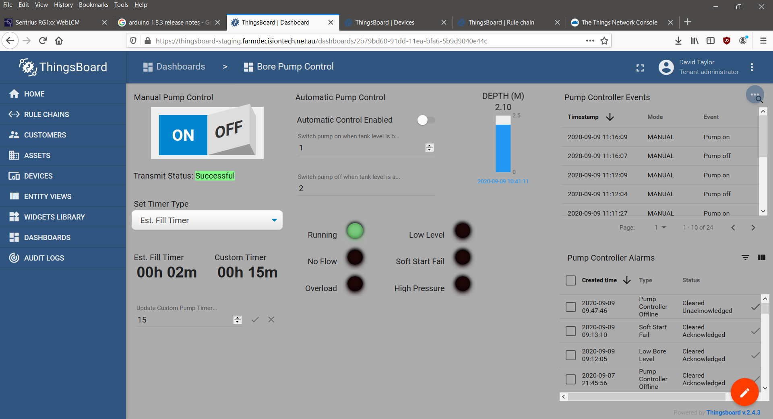

Step 5.

11:19:07.802 -> Pump run timer has expired. Turning pump off.

11:19:07.802 -> Switched pump off.

11:19:07.802 -> Sending status due to state change.

11:19:07.802 -> LoRaWAN will encode and send this message: {'pumpRunning':0,'boreLowLevel':0,'softStartFail':0,'pumpOverload':0,'controllerRestart':0,'highPressure':0,'noFlow':0}

11:19:07.802 -> Sending status byte: 00

11:19:09.907 -> EV_TXCOMPLETE (includes waiting for RX windows)

